### Problem 1

Suppose that a disk has storage capacity of 1TB and a block size of 4096 bytes. We have a table with 100,000 records each record has a size of 2050 bytes. Answer these questions:

1. What is the total capacity of RAID 0 with 10 drives?

Because RAID 0 has no data redundancy, so the total capacity is 10*1TB = 10TB.

1. What is the total capacity of RAID 5 with 10 drives?

RAID 5 needs one additional drive per RAID group for parity information, so the capacity would be 9*1TB = 9TB.

1. How many blocks are needed for spanned and unspanned records, respectively?

For unspanned configuration, each record takes up one block, so 100,000 blocks are required. For spanned configuration, ceiling (100,000*2050/4096) = 500489 blocks are required.

1. What is the block (space) utilization in both cases?

For unspanned case, the space utilization rate is 2050/4096 = 0.5. For spanned case the utilization rate is 1.

1. Assume that the disk has a read bandwidth of 1 GB/sec. Suppose that data is stored sequentially. What is the time to read all records in the unspanned configuration?

t = 1e5*2052/1e9 = 0.2052s.

If records do not exactly fit in a block, we have two choices: (i) Waste the space at the end of each block and (ii) Start a record at the end of a block and continue on the next. Choice (i) is the **unspanned** option. Choice (ii) is the **spanned** option.

**Problem 2**

Consider a disk with the following specifications: sector size = 1024, 4000 tracks per surface, 100 sector s per track, 10 double-side platters, average seek time of 10 msec, and the disk platters rotate 7,200 rpm (revolutions per minute).

1. What is the capacity of a track in KBs (an KB = 1024 bytes)?

100*1024 bytes = 100 KB

1. What is the capacity of each platter surface?

For one-side surface, the capacity = 100*4000 KB = 390.625 MB

For double-side surface, the capacity = 2*390.625 MB = 781.25 MB

1. What is the capacity of the disk?

The capacity of the disk = 781.25 MB * 10 = 7812.5 MB

1. How many cylinders does the disk have?

4000

1. What is the maximum rotational delay?

60*1000/7200 = 8.333 msec

1. If an entire track of data can be transfer per revolution, what is the transfer rate?

Transfer rate = data capacity per track/(seek time + maximum rotational delay) = 12 MB/s

**Problem 3**

Consider a B+-tree of order 2 (i.e., d = 2 and max. keys=4). Insert the following keys in order: 10, 20, 60, 7, 30, 66, 1, 73, 2, 85, 9, 88, 95, and 90.

1. Show the final tree. Part points will be awarded for each correct insert if you show your intermediary work.

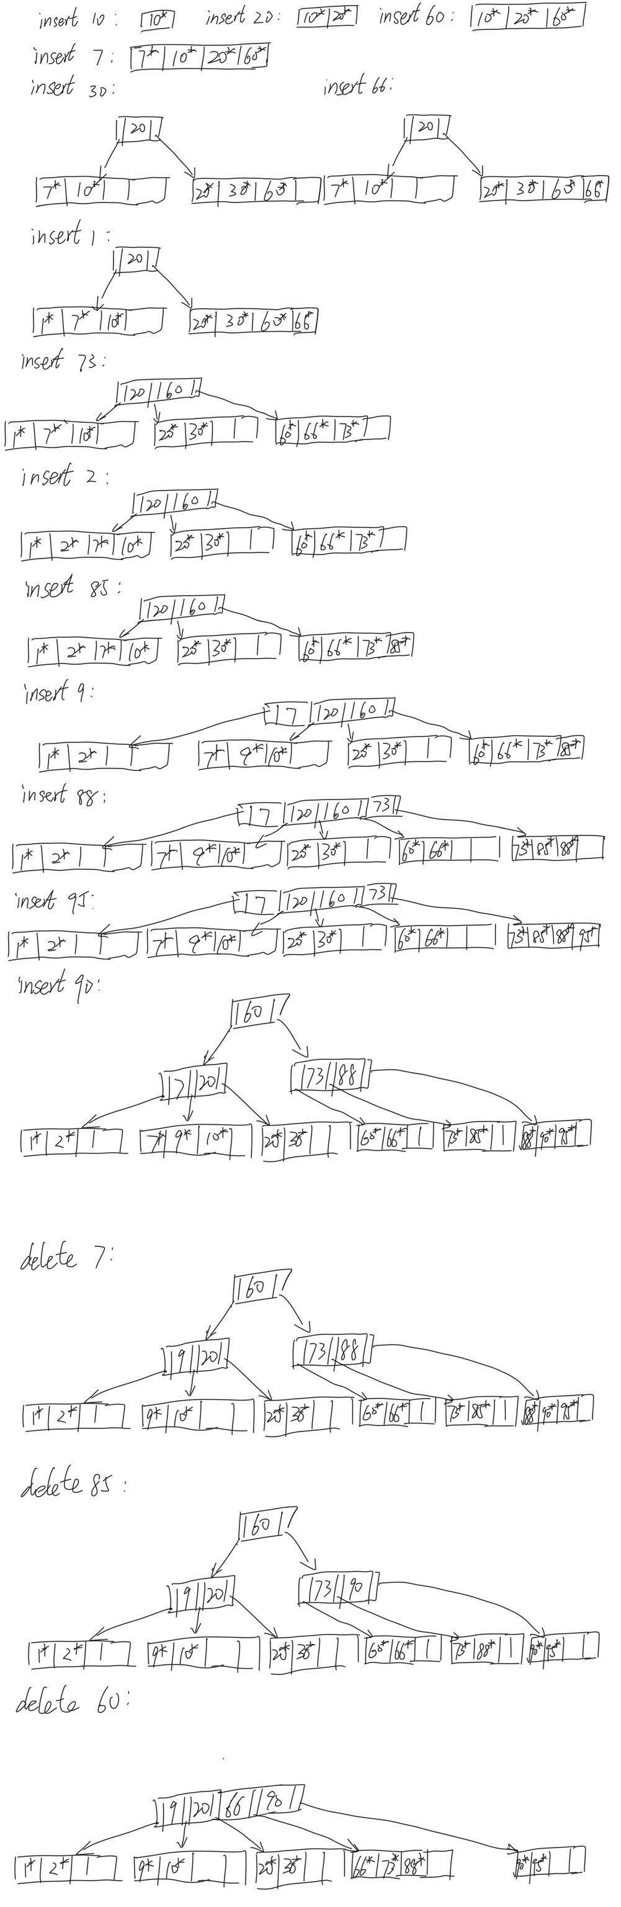



1. Show the tree after each of the following deletions: 7, 85, 60.